20th April 2023

Dear Parent/Carer,
Re: Year 7; Year 8; Year 9; Year 10; Year 12 on Thursday 27th April 2023 and Tuesday 2nd May, day of the Teachers Strike
You would have heard that the teachers are planning a number of strikes, the next ones being on Thursday 27th April and Tuesday 2nd May 2023. If there is any change to these planned strike days, we will place an update on our website and write to you directly.
Therefore, the students in the above years will not be able to come to school. They will need to stay at home and be revising from their books, given to them by their teachers. They will need to create ‘mind maps’ or ‘revision cards’ which will support their progress, in exams.
Students who have EHCP, or are considered to be vulnerable, will be able to attend school as normal.
Students who are Free School Meals can be sent to school, in full uniform, for normal lunch time. After their lunch they will be sent home.
Please accept my sincere apologies for the disruption this might cause to you and your child, but it is beyond the school’s control.
If you would like to talk about any element of this letter then please contact me.
Yours sincerely
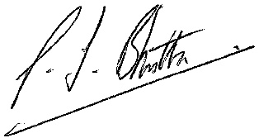

Mr Bhutta
Headteacher

