20th April 2023

Dear Parent/Carer,
Re: Year 13 and Year 11 students on Thursday 27th April and Tuesday 2nd May 2023, days of the Teachers Strike
You would have heard that teachers are planning a number of strikes, the next ones being Thursday 27th April and Tuesday 2nd May. If there is any change to these planned strike days, we will place an update on our website and write to you directly.
The students in Year 13 and Year 11 must come into school on the 27th of April and 2nd May 2023. Their exams are near and the days will be used to prepare them for their exams.
All Year 11 and Year 13 students must be in school on the 27th April and 2nd May 2023, fully equipped for learning in their normal dress/uniform. All year 11 students will be taught their option subjects and year 13 students will be taught subjects according to their blocks
Yours sincerely

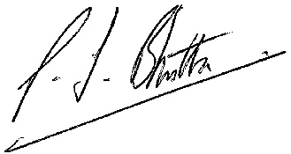

Mr Bhutta
Headteacher

