9th March 2023

Dear Parent/Carer,
Re: Year 13 and Year 11 students on Wednesday 15th March and Thursday 16th March 2023, days of the Teachers Strike
You would have heard that teachers are planning a number of strikes, the next ones being Wednesday 15th March and Thursday 16th March. If there is any change to these planned strike days, we will place an update on our website and write to you directly.
The students in Year 13 and Year 11 must come into school on the 15th and 16th March 2023. Their exams are near and the days will be used to prepare them for their exams.
All Year 13 and Year 11 students must be in school on the 15th and 16th March 2023, fully equipped for learning in their normal dress/uniform.
Yours sincerely

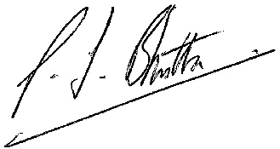

Mr Bhutta
Headteacher

